In Roxbury, 13 candidates fight for a council seat — and to preserve a community

**By Claire Parker** Globe Correspondent, July 10, 2017, 8:29 p.m.

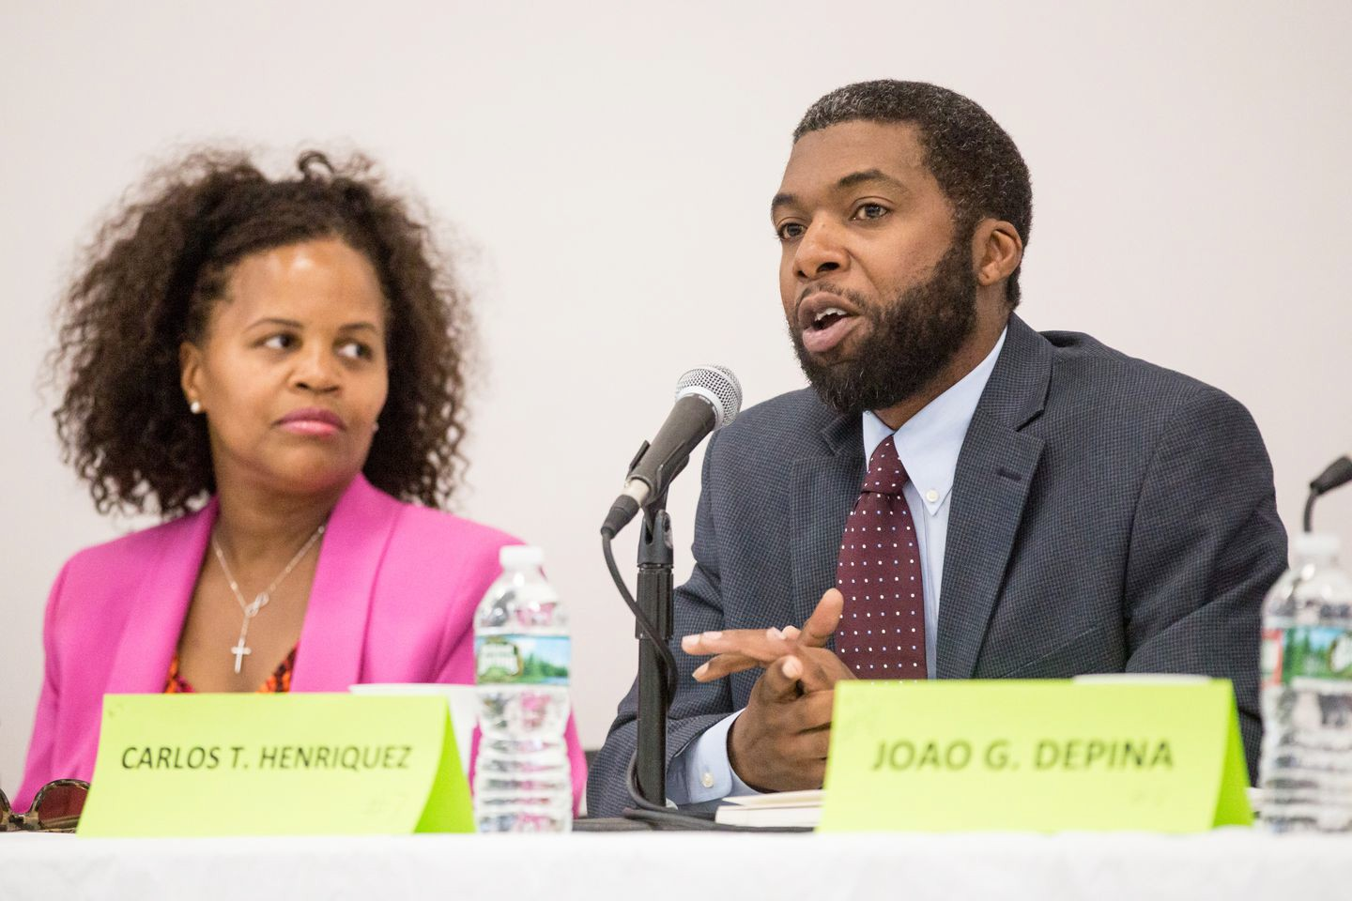

City Council hopefuls Kim Janey (left) and Carlos Henriquez were among 11 District 7 candidates running who addressed voters during a forum last month. District 7 incumbent Tito Jackson is giving up his seat to run for mayor. ARAM BOGHOSIAN FOR THE BOSTON GLOBE

The irony is not lost on Malaysia Fuller-Staten. The 2o-year-old has watched opportunities dwindle for young people like her who grew up in Roxbury, even as a new crop of residents moves in.

“This is a community that was generally full of people of color, and now, you know, there are white people moving in,” she said. “I just wonder when this part of the city became so valuable — became a place where people wanted to live, at the expense of the people who live here and made it somewhere valuable.”

At a recent community forum for the District 7 City Council race, Fuller-Staten and many of her neighbors identified gentrification as the top issue confronting Roxbury, which has long prided itself on being the heart of black culture in Boston. As Boston’s economy booms, the district — which cuts across Roxbury, Fenway, and the South End

— is at a crossroads. Many of the area’s neighborhoods are still struggling financially even as more affluent newcomers are displacing longtime residents.

It’s a microcosm for citywide challenges related to gentrification and income inequality. And now that the district’s city councilor, Tito Jackson, is giving up his seat to run for mayor, 13 candidates are vying to become the area’s new voice at City Hall.

“What’s interesting in this district is that it crosses some of the most up-and-coming neighborhoods in the city and also some of the poorest, so in many ways it represents the inequality that the city is going to have to grapple with,” said Katherine Levine Einstein, a Boston University political science professor who studies urban politics.

Eleven of those 13 candidates showed up last month at the Roxbury forum, where about 200 residents filled the auditorium to watch them present their visions for the district.

Shaikh Hasib, an aide for at-large councilor Michael Flaherty and a volunteer with the community organizations that sponsored the event, said he thinks the unusually large slate reflects a nationwide uptick in members of underrepresented groups running for office.

“We are at a point where we are seeing more and more people across the country of diverse backgrounds stepping up and putting their names on the ballot,” Hasib said.

This phenomenon is particularly evident in a district trying to retain that diversity. The 11 candidates at the forum, all of whom were black or Latino, personify the constituencies and experiences that characterize the district — or at least, its old guard. Angelina Camacho was born to parents who moved from Honduras to Rockland Street. Joao DePina, who grew up in foster care and lost a brother to gun violence, provides counseling to traumatized families. Rufus Faulk directs a gang mediation initiative.

Children’s advocate Kim Janey comes from a family that has lived in Roxbury for nearly a century. Deeqo Jibril, meanwhile, moved to the area as a refugee from Somalia in 1991 — and has since started six local businesses. Brian Keith is president of his neighborhood association in Roxbury. Charles Clemons Muhammad, who ran against Jackson in 2015, is a former Boston police officer and corrections officer.

Attorney Hassan Williams used to be homeless. And Roxbury-born Domonique Williams is returning to the district after graduating from Howard University School of Law. Jose Lopez taught in the Boston Public Schools for years.

The 11th candidate was Carlos Henriquez, the area’s state representative before he was expelled in 2014 after he was convicted of assault charges.

(The other two candidates, who did not attend the forum, are Roy Owens and Steven Wise.)

Many have lived in the district for years, if not generations — a point they emphasized repeatedly at the forum as they sought to ally themselves with longtime inhabitants against the encroachment of outsiders and developers.

Jackson, who has made affordable housing a cornerstone of his mayoral campaign, said in an interview that when he took office in 2011, 15 to 20 development projects were underway at a time. Now, he said, that number has tripled.

“There is a lot of fragility in the housing market in Roxbury that could completely wipe out the community as we know it,” Jackson said.

Steven Godfrey, president and CEO of the Quincy Geneva Housing Corporation/New Vision CDC — an organization that helps area residents find affordable housing — described Roxbury as the “gateway to the city.”

With large tracts of publicly owned, undeveloped land, it is prime real estate for developers. One is pushing a plan to construct a 25-story mixed-use tower in Dudley Square. And in 2016, the Boston Planning & Development Agency unveiled a proposal to build up four vacant lots in that area — which Jackson and many residents responded to with resistance. The agency has held a series of public meetings since then to discuss their concerns.

Asked what issues mattered most to her as a voter, Valerie Shelley — who is the president of a neighborhood association in Roxbury — didn’t skip a beat. “Housing and education and jobs,” Shelley said.

“Affordable housing — let me quote ‘affordable,’ ” she backtracked. “Affordable for the residents of Boston, not affordable to developers. There’s a big difference.”

Candidates offered a range of fixes: negotiating with developers (Keith), setting aside at least 30 percent of new developments for affordable housing (Jibril), opening more rooming houses (Williams), and taxing Boston’s universities to pay for transitional housing (Lopez).

Behind affordable housing, District 7 voters and candidates pointed to education as their next most pressing concern, and many spoke about the need to improve area schools. Candidates also proposed ideas for curbing violence, improving community relations with police officers, tackling homelessness, and providing opportunities for youth.

With such a large slate, it can be difficult to discern front-runners at this stage. Fund- raising can provide a clue, Einstein said.

Janey has a sizable lead, with $30,138 in her campaign account. Jibril has nearly

$20,000, followed by Hassan Williams at $13,000, and DePina at around $11,000. The other candidates have all raised less than $10,000.

But Michael Johnson, a professor of public policy at University of Massachusetts Boston, said that in local elections, sizable war chests are less important than on the state or national stages.

“You may not need a lot of money to make a difference if you’re clever and strategic in how you use it, and if you and your volunteers are willing to expend a whole lot of personal time and shoe leather,” Johnson said.

“Five thousand dollars gets you reasonably far,” he added. “But less than $1,000 — it’s hard for me to see how you could do anything meaningful with that.”

But one candidate who lags behind significantly in fund-raising seemed to be a crowd favorite at the forum. Former state representative Henriquez’s name recognition and straight-talking style made him stand out to some attendees.

“I’m going to talk to you really plainly and honestly, because I love you,” Henriquez told the audience — eschewing sweeping promises on housing and education in favor of focusing on the more mundane aspects of city governance, like choosing a worthy council president.

Longtime Roxbury resident Regina McClay was one of those who favored Henriquez.

“Mr. Henriquez had the more realistic approach to what he would do on the first day

— always get an assessment as to what is there, before you start talking about housing,” she said. “I don’t think anyone defined what affordable housing was, what equity in education is, and how we move forward in the community addressing those issues.”

Diving deep enough into policy questions to differentiate among the many candidates proved difficult at this stage, forum attendees said. Einstein predicted that as the race progresses, though, some candidates will likely lose money or steam — making the viable contenders more apparent by September.

Whoever emerges victorious will have to be ready to speak out loudly on behalf of a district whose residents feel marginalized, Jackson said. “As District 7 city councilor, you have to be a fighter,” he said.

*This story has been changed to reflect that City Council candidate Carlos Henriquez was expelled from the the state Legislature after he was convicted of assault and battery.*

Claire Parker can be reached at [claire.parker@globe.com.](mailto:claire.parker@globe.com) Reach her on Twitter @ClaireParkerDC.

**Show 21 comments**

©2021 Boston Globe Media Partners, LLC